Photo Contest Essay

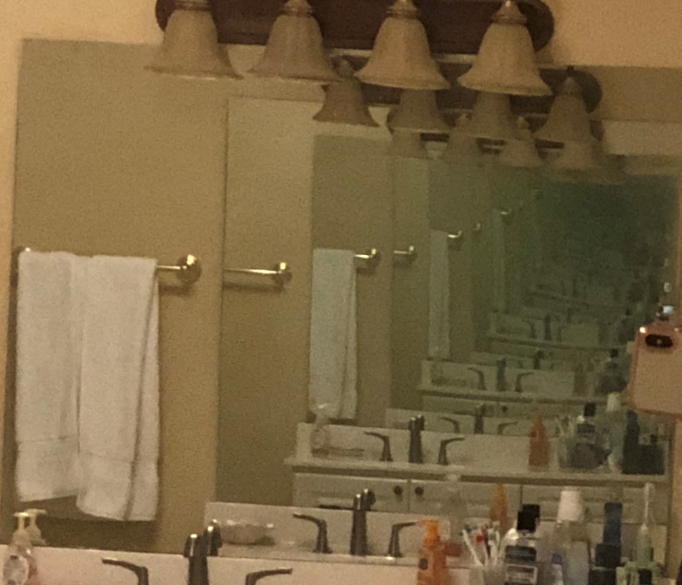According to the law of reflection, an incident ray strikes a surface at a certain angle relative to the "normal", a line perpendicular to the mirror’s surface. This law of reflection is used in physics to identify the location of an image that is reflected in a mirror. When two mirrors are placed at different angles different number of images are formed in the mirror. But when two mirrors are situated in front of each other they have a 0-degree angle between them, so recurring images are formed. An object placed in front of the parallel mirrors seem to from an infinite number of images on the mirror. This image is a result of an image of an image, or an image of an image of an image and so on. In reality, images aren't truly infinite because tiny imperfections in the mirror surface eventually propagate and extinguish the image.